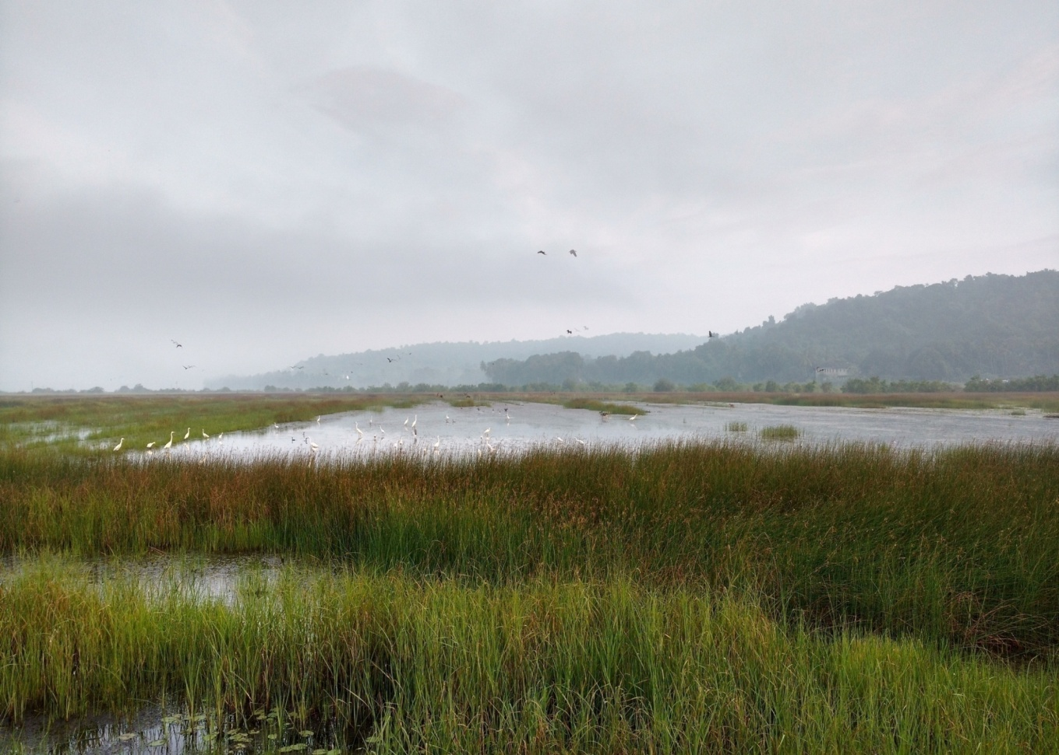

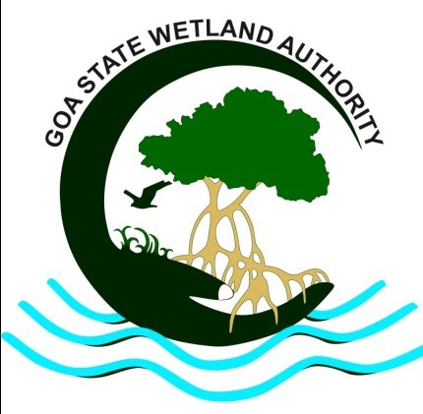
Celebration of World Wetlands Day, 2018
by
Goa State Wetland Authority
Place: Dr. S. Z. Qasim Auditorium, National Institute of Oceanography, Dona-Paula
Date: 02nd February 2018
Time: 10:00 am to 05:15 pm

Introduction
Wetlands are under threat globally, occasionally a natural process threatens the existence of a wetland but in the majority of the cases it is the way human uses the natural resources in unsustainable manner which has posed a great threat to our biodiversity. Wetlands and biodiversity are interdependent. Knowing the value of these precious resources is of prime importance in the present scenario and future to come. Even in the 21st century, the general level of awareness on biodiversity, water resource and the issue of species loss remain largely unknown. Raising general awareness on water, biodiversity, extinction of species and need for conservation is absolutely necessary
The State of Goa is blessed with abundant rainfall from the South-West monsoonal winds. Though the State has high potential for assured water supply, a high percentage of water gets drained and joins the Arabian Sea due to the physiographical set up of the State. The surface drainage is facilitated by many streams, nullahs, rivulets and rivers which run across the State. Despite of these natural constrains a lot of water bodies are misused, left unattended and polluted by the people.
Background
Inorder to raise global awareness about the value of wetlands for humanity and the planet World Wetlands Day is celebrated every year on 2nd February. It also marks the date of adoption of the Ramsar Convention on Wetlands in 1971, in the Iranian City of Ramsar. World Wetlands Day was celebrated for the first time in 1997.
Goa State Wetland Authority (GSWA) with the support of Ministry of Environment, Forests and Climate Change (MoEF&CC), Department of Environment, Goa and Goa State Biodiversity Board (GSBB) celebrated the World Wetlands Day, 2018 on 02nd February 2018 from 10:00 am to 05:15 pm at Dr. S. Z. Qasim Auditorium, National Institute of Oceanography (NIO), Dona-Paula, Goa in the distinguished presence of Dr. Kuldeep Lal, Director, ICAR-NBFGR, Lucknow; Dr. Sunil Kumar Singh, Director, National Institute of Oceanography, Goa with the theme: “Wetlands for a Sustainable Urban Future”. It aimed to raise awareness about role of urban wetlands in making cities livable and their contribution to the future of sustainable cities

Inaugural Session

The dignitaries present on the dais were: Chief Guest for the function was Dr. Kuldeep Lal, Director, ICAR-NBFGR, Lucknow; Dr. Sunil Kumar Singh, Director, National Institute of Oceanography, Goa (Guest of Honour); Shri. Parag Nagarcenkar, Director, Department of Environment and Member Secretary, GSWA; and Shri. Pradip Sarmokadam, Member Secretary, Goa Sate Biodiversity Board.
Shri. Parag Nagarcenkar, Director, Department of Environment and Member Secretary, GSWA welcomed the guests, speakers and all the delegates. It was followed by floral welcome to the dignitaries on dais.
The function was formally inaugurated by lighting the traditional lamp by the dignitaries on the dais and Chairpersons of Biodiversity Management Committees (BMC).
Dr. Sunil Kumar Singh, Director, National Institute of Oceanography, Goa during his speech mentioned that wetlands influence microclimate and add to the aesthetic beauty of Landscape. Further he also said that, wetlands acts as sponge and play a vital role in removing toxic substances and sediment from water, while also improving downstream water quality and the overall health of the ecosystem.
Dr. Kuldeep Lal, Director, ICAR-NBFGR, Lucknow stated that wetlands are significant source of water and provide habitat to a variety of flora and fauna and further suggested that urban wetlands should be integrated into a city’s sustainable future planning and development. He urged the gathering to conserve wetlands and as far as possible to use it sustainably. It was a very thought provoking speech. He also congratulated GSBB for taking the initiative to raise public awareness about the importance and value of wetland ecosystem.
On this occasion two posters and a brochure with the message of important ecological and socio economic services of wetlands published by Goa State Wetland Authority and Goa State Biodiversity Board were released at the hands of Chief Guest and Guest of Honour.
The mementos of the World Wetlands Day, 2018 were presented to the dignitaries on the dais by the Shri. Parag Nagarcenkar, Director, Department of Environment and Member Secretary, GSWA.
Vote of thanks was proposed by Shri. Pradip Sarmokadam, Member Secretary, Goa Sate Biodiversity Board.
End of inaugural session (Itinerary placed at Annexure I)
Technical Session with presentations from eminent speakers
After the inaugural session presentations were delivered by Dr. G. N. Nayak, Professor, Goa University; Shri. Ajai Saxena, IFS, Principal Chief Conservator of Forests, Government of Goa, Dr. Kuldeep Lal, Director, ICAR-NBFGR, Lucknow and Dr. Pranab Mukhopadhyay, Professor, Goa University.
Dr. G. N. Nayak
Dr. Nayak gave a very informative presentation titled: ‘Wetlands and Man’. Dr. Nayak simplified the definition of wetlands as a land area that is saturated with water, either permanently or seasonally. He explained in detail the role of BMCs in identification and conservation of wetlands. He expressed his discontent over absence of Ramsar site in the State of Goa and cautioned the audience over the increasing trend in sediment metal concentration in the estuarine system.

The lecture was followed by the interactive session with the audience and Dr. G. N. Nayak.

Shri. Ajai Saxena
Shri. Ajai Saxena gave a lecture on ‘Importance and sustainable uses of wetlands’ with many examples of wetland conservation and sustainable use. Emphasis were on Vedanthangal Wild Life Sanctuary, Tamil Nadu; Keolodeo Ghana, Bharatpur; Mahatma Gandhi Marine National Park, South Andaman and Dr. Salim Ali Bird Sanctuary, Chodan. He urged the members of BMCs to involve the youngsters in the process of conservation of wetlands in Goa.

The lecture was followed by the interactive session with the audience and Shri. Ajai Saxena.
Dr. Kuldeep Lal
Focused on the exotic germ plasm and invasive risks, Dr. Kuldeep Lal gave a very informative presentation on ‘Aquatic genetic resource management: Global relevance and national action’. He stressed that effective conservation and management of biodiversity in large part of our understanding of taxonomy is essential for sustenance of natural resource as well as for genetic improvement programmes. He informed the audience that the use and exchange of aquatic genetic resources helped aquaculture to become the fastest growing food producing sector.
The lecture was followed by the interactive session with the audience and Dr. Kuldeep Lal.
Dr. Pranab Mukhopadhyay
Dr. Pranab Mukhopadyay gave a presentation on ‘Wetlands and wellbeing’ and informed the audience that 1/8th of the ecosystem services comes from wetlands, however lack of community awareness on the value and benefits of wetlands often leads to their transformation by humans.

The lecture was followed by the interactive session with the audience and Dr. Pranab Mukhopadyay.
Vote of thanks was proposed by Shri. Pradip Sarmokadam, Member Secretary, Goa Sate Biodiversity Board.
Around 137 enthusiastic delegates registered and over 150 people were present for the function with representation from 52 BMCs along with other organizations and Government departments.

Some of the photographs captured on the occasion of the celebration of World Wetland Day, 2018

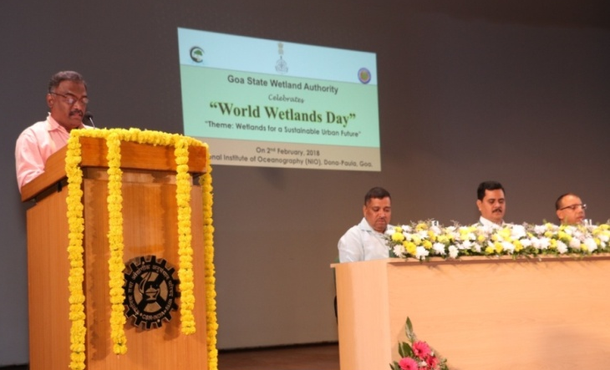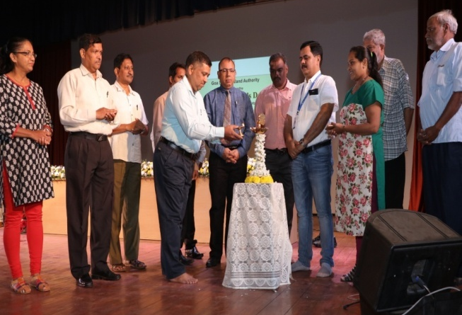
Shri. Parag Nagarcenkar, Director, Department of Environment; Lighting the traditional lamp by the dignitaries on the dais
Member Secretary, GSWA delivering welcome speech and Chairpersons of various BMCs

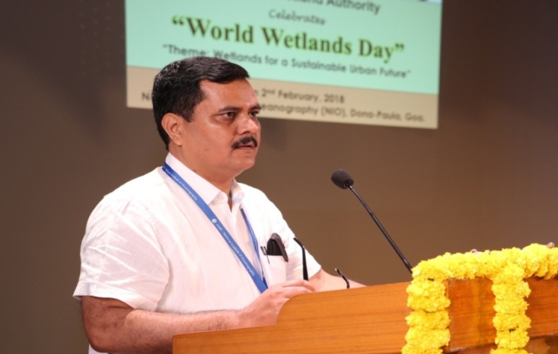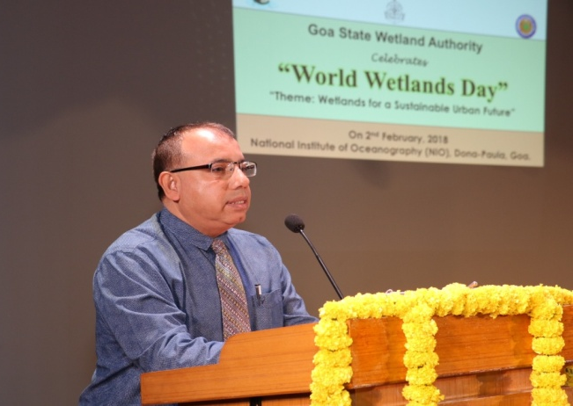
Dr. Sunil Kumar Singh, Director, NIO addressing the gathering Dr. Kuldeep Lal, Director, ICAR-NBFGR, Lucknow addressing
the gathering

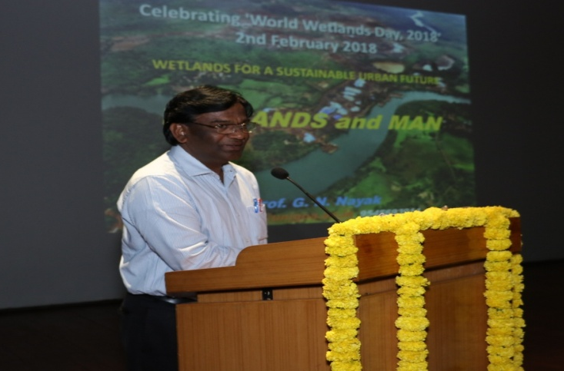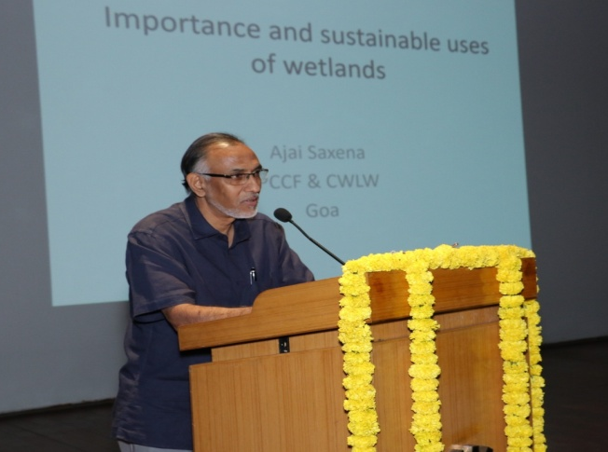
Dr. Nayak delivering a lecture on ‘Wetlands and Man’ Shri. Ajai Saxena delivering a lecture on ‘Importance and
sustainable uses of wetlands’

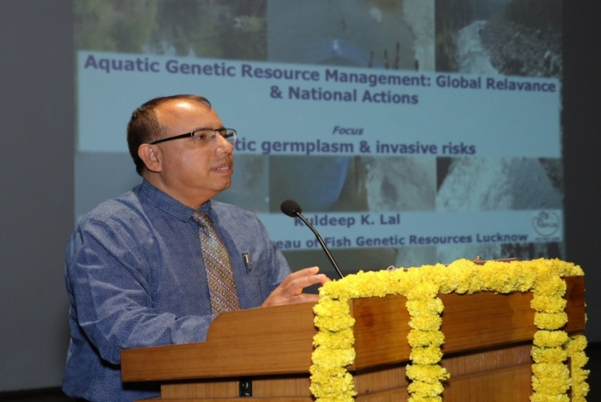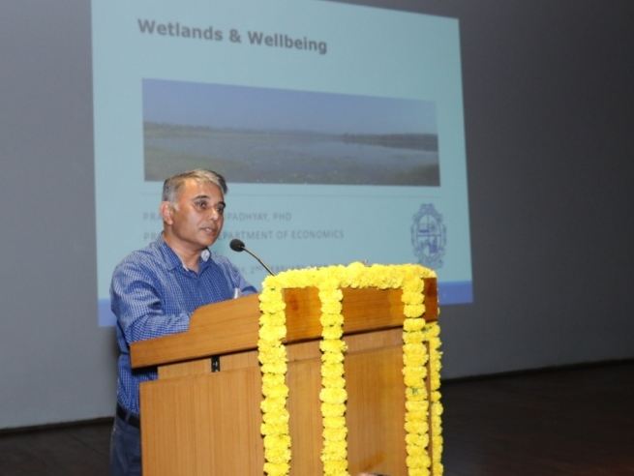

Dr. Kuldeep Lal delivering lecture on ‘Aquatic genetic resource Dr. Pranab Mukhopadyay delivering lecture on ‘Wetlands
management: Global relevance and national action’ and wellbeing’

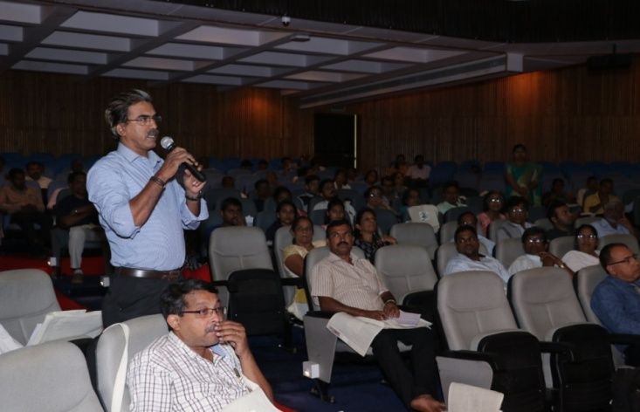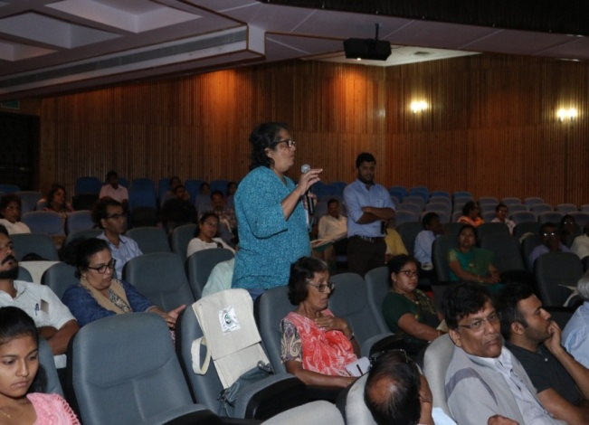
Audience interacting with the speakers during interactive session

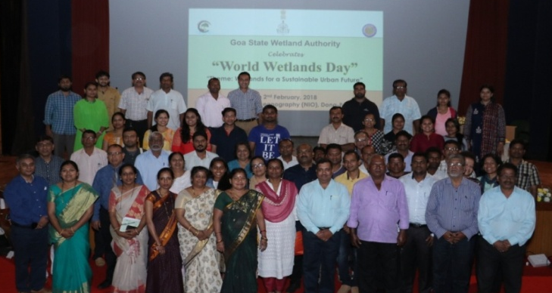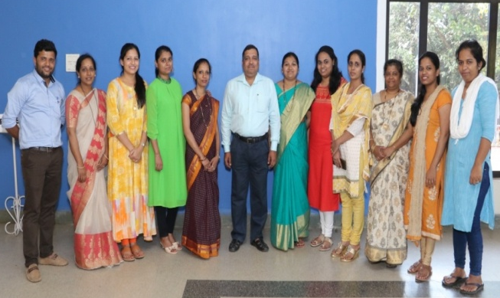
Group photograph Member Secretary,GSBB and team

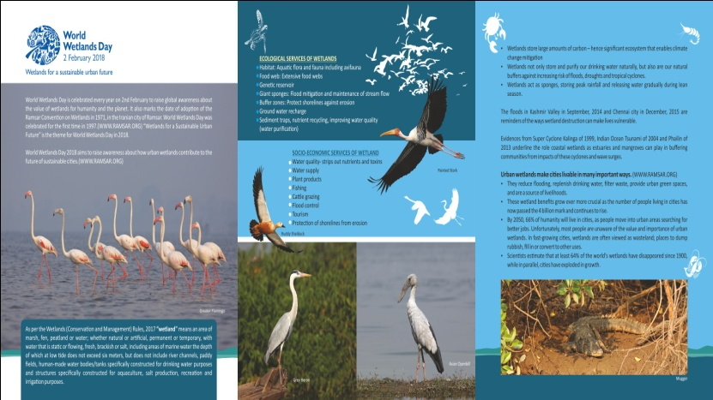
Pamplet (side 1) released on the occasion of celebration of World Wetlands Day- 2018

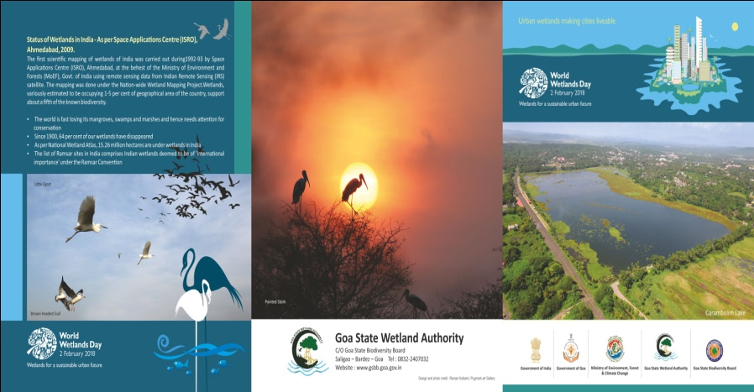
Pamplet (side 2) released on the occasion of celebration of World Wetlands Day- 2018

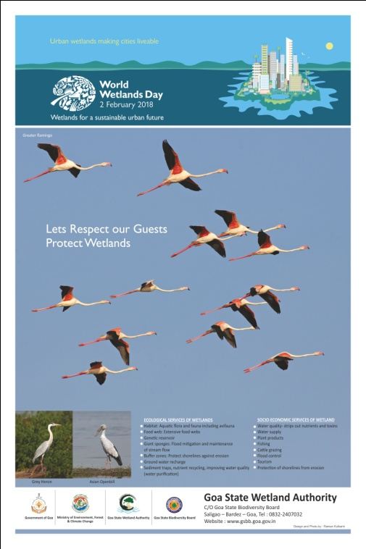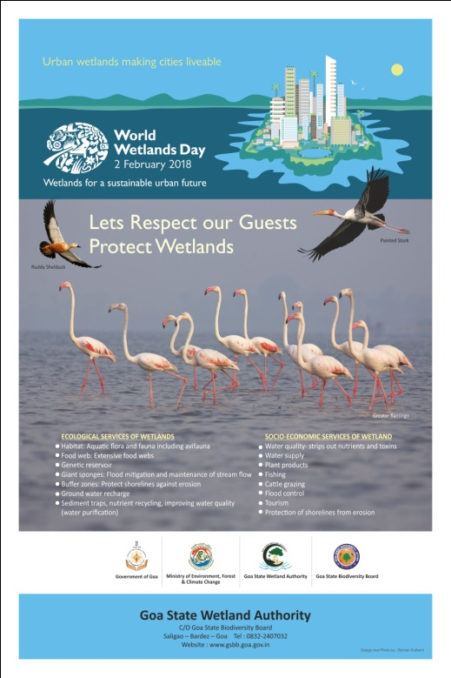
Posters released to the occasion of celebration of World Wetlands Day- 2018

