Report of Celebration of International Day for Biological Diversity 2016 (IDB-2016)
Theme: “Mainstreaming Biodiversity, Sustaining People & their Livelihoods”
Venue: Kala Academy – Panaji – Goa. Time: From 10 am to 5 pm.

Session 1: Inaugural Session

Goa State Biodiversity Board (GSBB) celebrated the International Day for Biological Diversity 2016 on this year’s Theme: “Mainstreaming Biodiversity, Sustaining People & their Livelihoods”, on 22nd May 2016 with the support of National Biodiversity Authority (NBA). The inaugural session was held at the “DinanathMangeshkar Auditorium”, Kala Academy, Panaji- Goa, from 9:30 am to 1:00 pm.

The dignitaries present on the dais included Chief Guest, Shri RajendraArlekar, Hon’ble Minister for Panchayats, Forest & Environment, Chairperson, GSBB; The Guest of Honour noted Environmental Activist, Thinker, Author and Physicist Dr.Vandana Shiva; Dr. R. Hampaiah, Former Chairperson, Andhra Pradesh State Biodiversity Board; Dr. Sharana Gouda, Assistant Controller of Patents & Design, Government of India, Patent Office, Intellectual Property Rights; &Shri. Pradip Sarmokadam, Member Secretary, GSBB. All the dignitaries on the dais were welcomed with fruit baskets by staff of GSBB.

The programme started with the lighting of traditional lamp at the hands of the dignitaries. Thereafter, Shri. Pradip Sarmokadam, Member Secretary, GSBB, welcomed the gathering. He highlighted briefly on the theme of IDB-2016 and welcomed the dignitaries, BMC representatives and other stakeholders. Two short speech were presented on the theme of IDB 2016 by winner of Elocution competition (Senior Category) held on 19th May 2016 Miss K. Sangeeta and a student & Volunteer with Biodiversity Management Committees Mr. DevanandNaik followed.
Both the presentations were highly appreciated by the audience which comprised of Biodiversity Management Committee members, Biodiversity Board members, Officers from Government Departments, Non- Government organization members, Biodiversity enthusiasts and general public.

Two personalities sustaining their livelihoods traditionally through biodiversity were felicitated on the occasion. 95 year old Shri. Antonio Fernandes alias Antonio Bandkar also known as protector of bundhs in South Goa, (bundhs are the embankments - wall like structures traditionally made using laterites using unique locally available binding material and techniques to protect intricate network of surface water bodies along the coastal villages) hailing from a traditional tribal agricultural family from the Village Curtorim, Salcete, Goa, was felicitated by Shri. RajendraArlekar, Hon’ble Minister for Panchayats, Forest & Environment, Chairperson, GSBB. Shri. Antonio was felicitated for his instrumental role in continuing the tradition of bundh sanskruti in Goa. He has been involved in agricultural practice of growing paddy (twice a year) as well as growing of different types of agrobiodiversity including vegetables in and around the Ralloi Lake at Curtorim. He still recalls vividly the story, regarding the construction of the main bundh of Ralloitollem(lake) (he recites this story in the song form) which is passed on to him generation after generation.

72 year old Mrs. Laxmi Vishnu Harvalkar hailing from Brahmakarmali of Village Nagargao, Sattari, North Goa, is not only a folk artist of high calibre but has done extensive work in enriching agricultural and horticultural bio-diversity of Goa through her efforts. Her contribution in maintaining Goa's bio-diversity is appreciable. She possesses good knowledge of ethnobotony and also about indigenous seeds. She was felicitated by Dr. Vandana Shiva for her work in enriching the agricultural and horticultural biodiversity of the State. Both the great individuals were recommended by BMCs and renowned environmentalists.

After the brief felicitation programme, the Chief Guest, Shri. RajendraArlekar, Hon’ble Minister for Panchayats, Forest & Environment, Chairperson, GSBB, addressed the gathering. He spoke at length about the rich traditional practices of conservation of Biodiversity followed by Goans for generations and how it was not necessary for them to be them to keep following this traditional knowledge handed over across generations.

He highlighted on traditional practices like the ‘Matoli’ a display of local fruits, cereals, medicinal herbs, etc., a feature common in all Goan Hindu homes during the Ganesh Festival.

He recounted how this display was earlier kept for the entire year and acted as a ready source for traditional homemade medicines for minor ailments. He also highlighted the fact that Goa Government is trying to curb the recently introduced malpractices of fishing causing harm to marine biodiversity. He also spoke about his plans to portray Goa as a bird watchers paradise, and to hold a bird festival in the near future wherein experts can share their experiences of bird watching and spread awareness about the same, at the same time to chalk out and follow a strategy to conserve the birding sites and develop more locations with potential as bird watching sites, so that not only the bird population is protected and conserved but also the entire habitat is saved for future generations.

The Guest of Honour, noted Environmental Activist, thinker, Author and Physicist Dr. Vandana Shiva, founder Navdanya (a national movement to protect the diversity and integrity of living resources – especially native seeds), recipient of the Right Livelihood Award also known as “alternative noble prize” for her work in placing women and ecology at the centre of the international development agenda delivered a inspiring lecture on the theme of IDB 2016. She highlighted and elaborated on this year’s IDB theme - “Mainstreaming Biodiversity, Sustaining People & their Livelihoods”, explaining how it was necessary to go back to our roots and traditions to sustain people and their livelihoods. How India can develop without losing touch with our agrarian roots, how more livelihoods can be generated through organic means of agriculture and horticultural practices. Role of some corporate in overexploiting biodiversity and how it was necessary to change this picture of India which is striving more towards being a corporate economy than an agrarian economy. How nature has been sustaining us and the absolute need of the hour being to protect and conserve nature. She spoke at length giving examples of malpractices of agriculture like use of harmful fertilizers, pesticides, insecticides etc.,and how she has been able to revert back to our traditional practices at ‘Navdanya’, how a desert can be transformed into a place abounding with biodiversity.

During the interactive session that followed, she also spoke about the Access Benefit Sharing and Intellectual Property Rights, explaining to members in the audience citing examples and answering a number of questions posed by the audience to their satisfaction.

The vote of thanks for the inaugural session was presented by Dr. Antonio Mascarenhas, Sr. Scientist & Expert Member, GSBB.

Session 2: Interactive session on Access Benefit Sharing & Intellectual property Rights.

The post lunch session was held at the “Black Box”, Kala Academy, Panaji- Goa, and included interactive session by Dr.Hampaiah, Former Chairperson, Andhra Pradesh Biodiversity Board on Access Benefit Sharing (ABS) of Biodiversity and Dr. Sharana Gouda, Assistant Controller of Patents & Design, Patent Office, Govt. of India, Intellectual Property Rights (IPR) on IPR for the Biodiversity Management Committee members from across Goa and Industrialists from Goa utilizing biological resources. This session was mainly aimed to help BMCs (Biodiversity Management Committees) and industries / business dependents on biodiversity understand about ABS & IPR.

Shri. Pradip Sarmokadam, Member Secretary, GSBB, presented memento to Dr. R. Hampaiah and Dr. Bhiva Malik, Expert member, GSBB, presented the memento to Dr. Sharana Gouda, after their respective sessions. Shri. Pradip Sarmokadam, Member Secretary, GSBB, gave the vote of thanks for the evening session. Both the inaugural session and interactive sessions were compeered by Smt. Tina Costa.

Entire program was well attended and was widely covered by media. There was an interview on FM rainbow 105.4 on 21st evening between 6 to 6:30 pm whereby live interview was held with Shri. Pradip Sarmokadam M.S. GSBB and one member from ChandelHansapur BMC Shri. Nilesh Naik.

GSBB has ensured video filming and photography of the event using professional services.

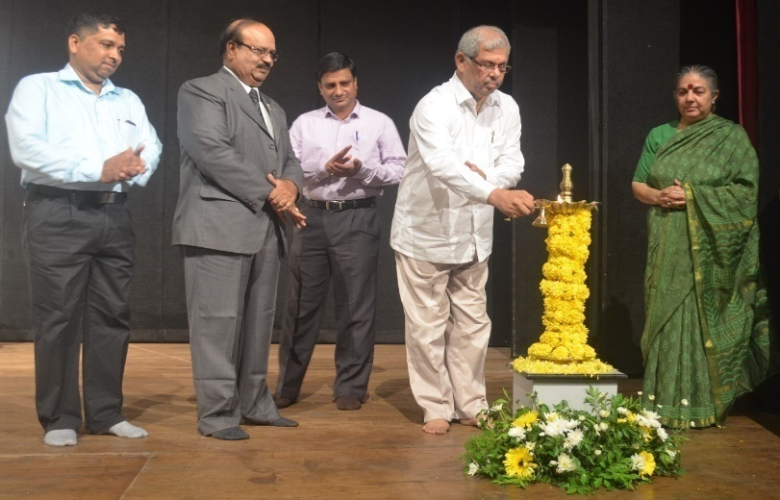Shri. RajendraArlekar, Hon’ble Minister for Panchayats, Forest & Environment; Chairperson Goa State Biodiversity Board (GSBB) lighting the traditional lamp to mark the inauguration programme of IDB-2016, also present from left to right Shri. PradipSarmokadam, Member Secretary, GSBB, Dr. R. Hampaiah, Former Chairperson Andhra Pradesh State Biodiversity Board, Dr. Sharan Gouda Assistant Controller of Patents & Designs, Patent office IPR & Guest of Honour Dr.Vandana Shiva Environmental Activist, Author and Physicist. | 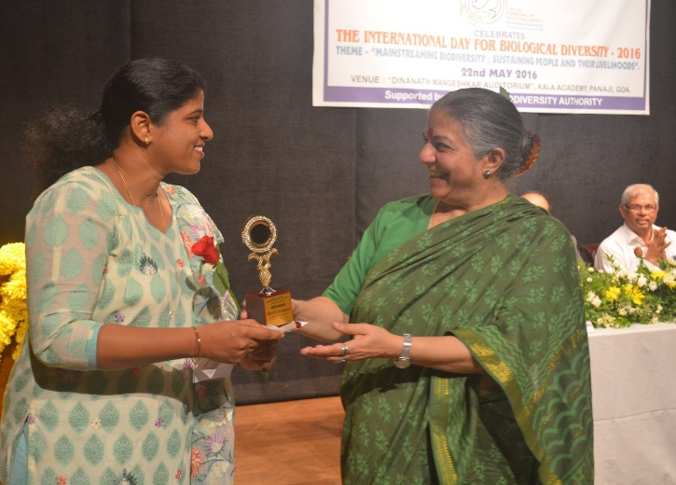Dr.Vandana Shiva Presenting trophy to winner of IDB-2016 Elocution Competition (Senior Category) Miss. K. Sangeeta
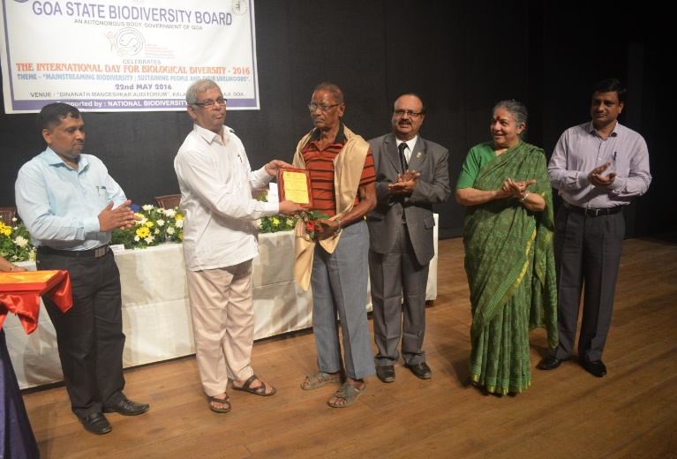Shri. Antonio Fernandes felicitated by Shri. RajendraArlekar, Hon’ble Minister for Panchayats, Forest & Environment; Chairperson Goa State Biodiversity Board (GSBB). | 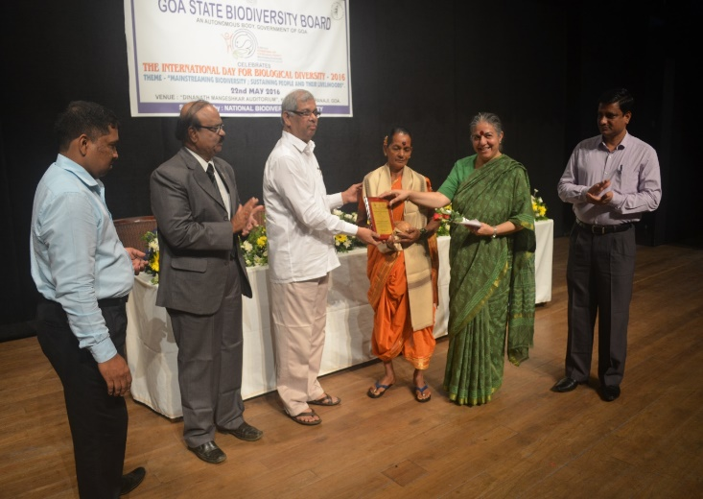Smt. LaxmiHarvalkar felicitated by Shri. RajendraArlekar, Hon’ble Minister for Panchayats, Forest & Environment; Chairperson Goa State Biodiversity Board (GSBB).
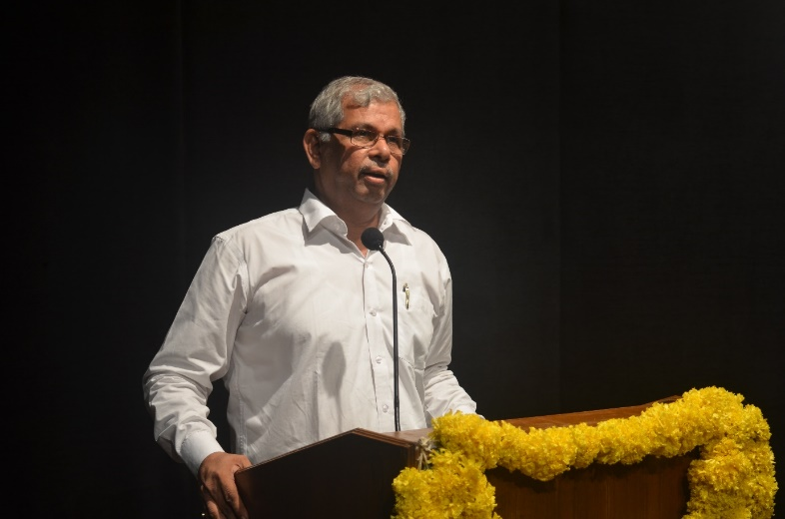Shri. RajendraArlekar, Hon’ble Minister for Panchayats, Forest & Environment; Chairperson ,GSBB, addressing the gathering. | 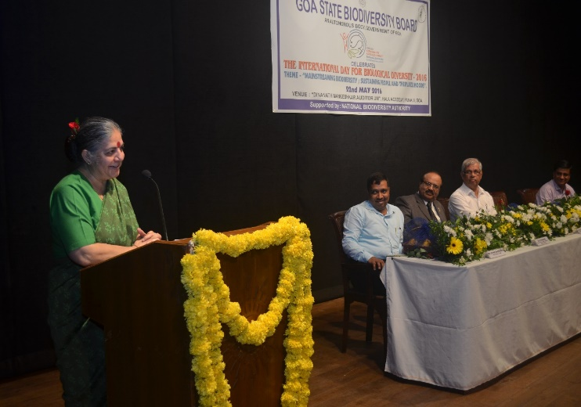Dr.Vandana Shiva addressing the gathering.
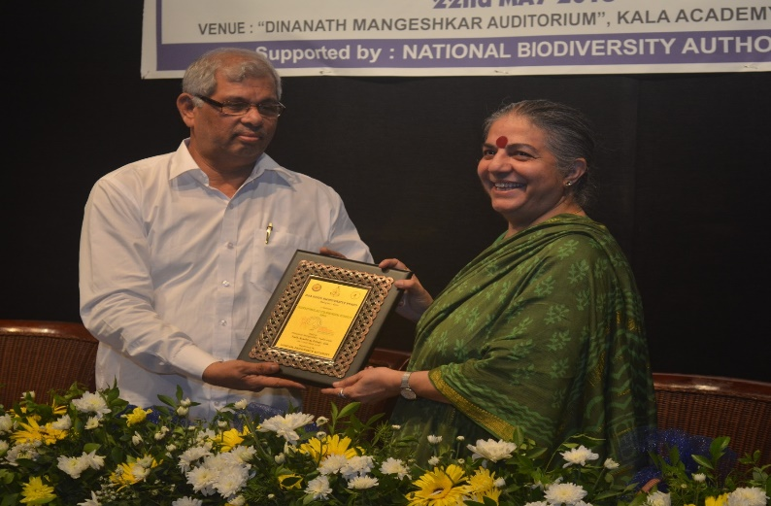Shri. RajendraArlekar, Hon’ble Minister for Panchayats, Forest & Environment; Chairperson Goa State Biodiversity Board (GSBB) presenting memento to Dr.Vandana Shiva. | 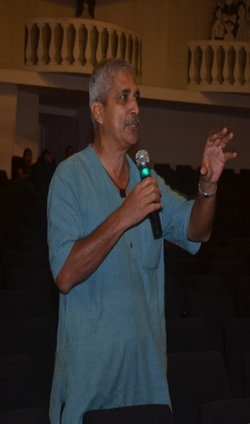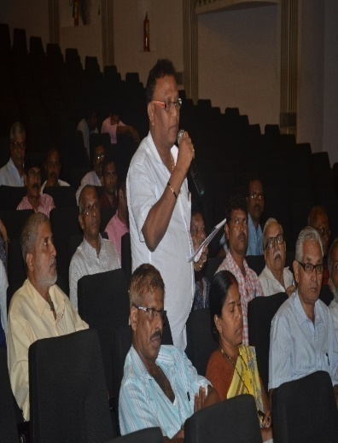Members of Audience interacting with Dr.Vandana Shiva.
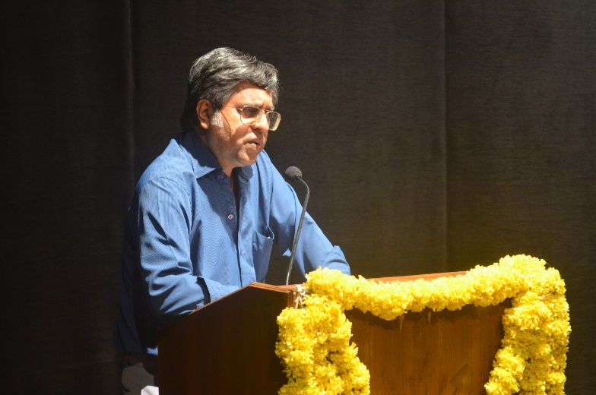Dr. Antonio Mascarenhas, Expert Member, GSBB presenting the vote of thanks at the inaugural session of IDB-2016 | 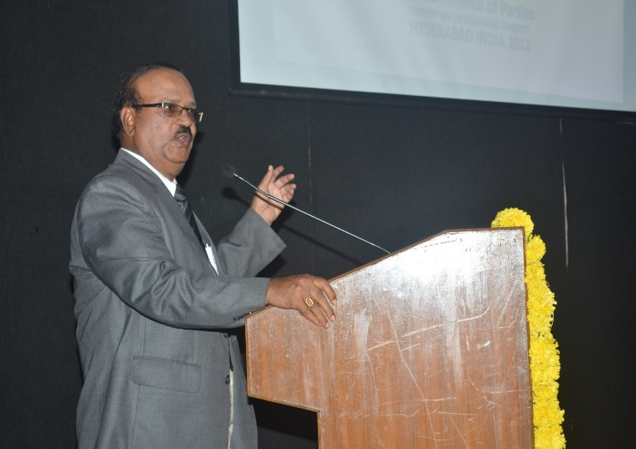Dr. R. Hampaiah, Former Chairperson, APSBB during interactive session on ABS.
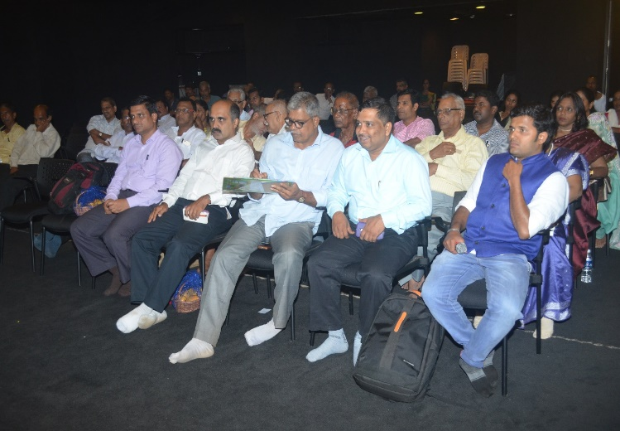 Members of Audience at Black Box, Kala Academy, Panaji- Goa, during interactive sessions on Access and Benefit Sharing (ABS) and Intellectual Property Right (IPR) | 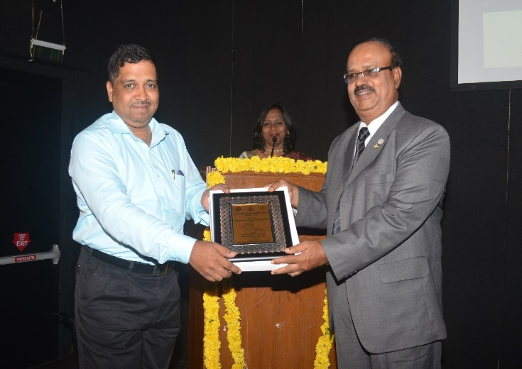Shri. PradipSarmokadam, MS, GSBB Presenting memento to Dr. R. Hampaiah.

