- Celebration of International Biological Diversity Day 2015:

On the occasion of celebration of International Day for Biological diversity 2015 and considering this year’s theme “Biodiversity for Sustainable Development”, Goa State Biodiversity Board (GSBB) with the support of National Biodiversity Authority (NBA) took an initiative to create awareness about Biodiversity among Biodiversity Management Committee members, local communities including the farmers, fishermen and artisans along with officials of various Government departments, members of NGOs and general public.
The Goa State Biodiversity Board (GSBB) held drawing & painting competition for school students, an essay competition for students of Higher Secondary Schools & Colleges of Goa, at the Conference hall of the Department of Science, Technology & Environment, Saligao, Goa, on 29th May 2015 and a day long program for the celebration of International Day for Biological Diversity (IBD- 2015) on 5th June 2015 at the Abolim hall of International Centre Goa, Dona Paula- Goa.
- Drawing and painting competition:
The drawing and painting competition was held on 29th May 2015 with the theme “Biodiversity for Sustainable Development” for the school children of standard 7th to 9th.
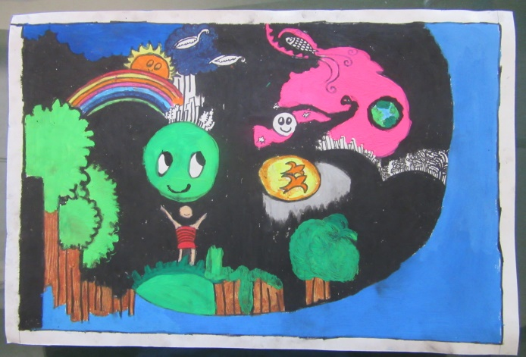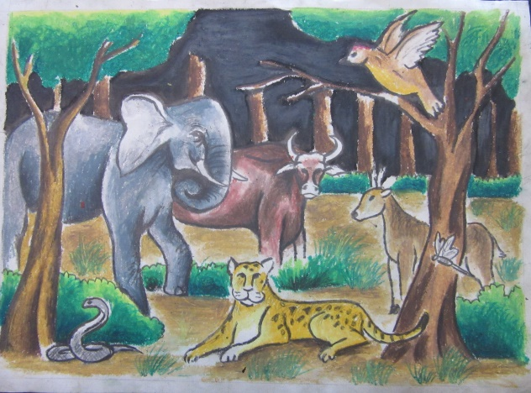
.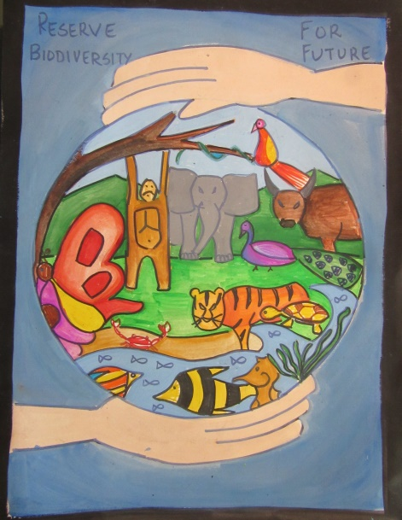
Some Entries of the Drawing & Painting Competition

- Essay competition:
Essay competition on the theme “Biodiversity for Sustainable Development” was held on 29th May 2015 for the students of Higher Secondary Schools & Colleges of Goa.

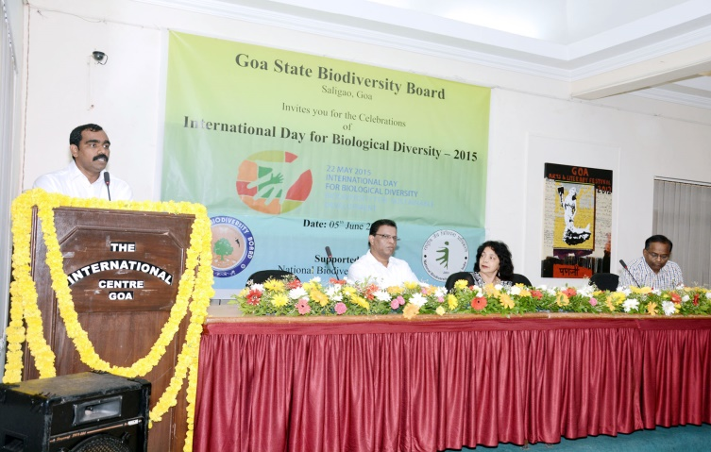 | 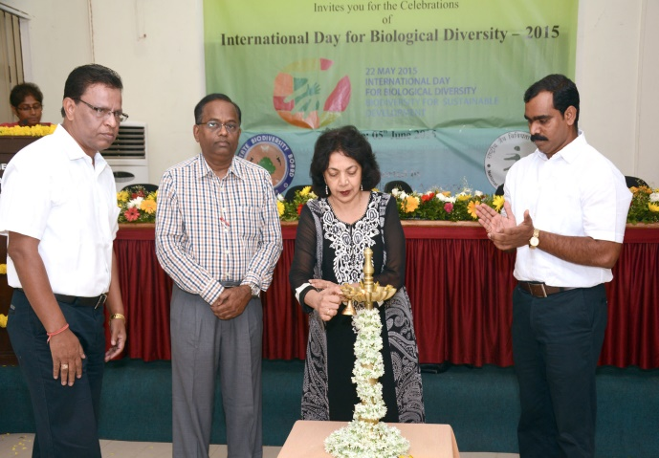
Dr. Nitin Sawant introducing the Dignitaries on the dais during the inaugural session on the occasion of the celebration of IDB- 2015 | Smt. Alina Saldanha, Hon’ble Minister for Forest & Environment, Goa State, & Chairperson Goa State Biodiversity Board, lighting the traditional lamp to mark the opening of the IDB function.
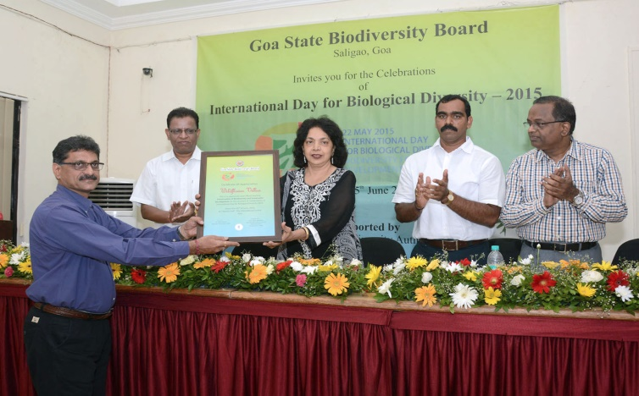 | 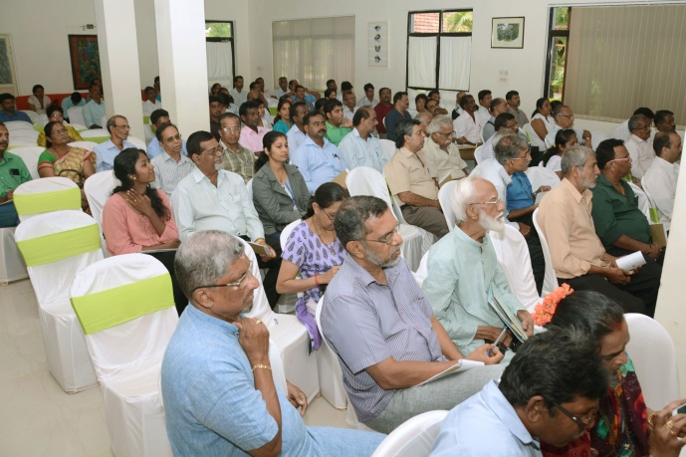
Proprietor of ‘Wildflower Villas’ receiving the Certificate  of Appreciation on the occasion of celebration of IDB- 2015 | Section of the Audience during the inaugural session of IDB 2015
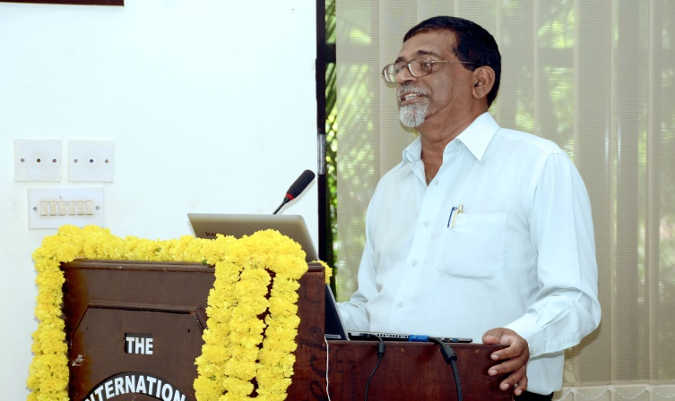 | 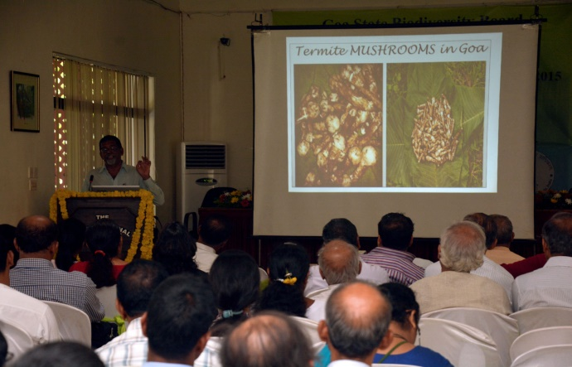
Shri. Miguel Braganza, Director of Organic Farming Association of India & Horticulture Consultant, delivering lecture on “Conservation of Biodiversity for Sustainable Development” | Lecture by Shri. Miguel Braganza in Progress
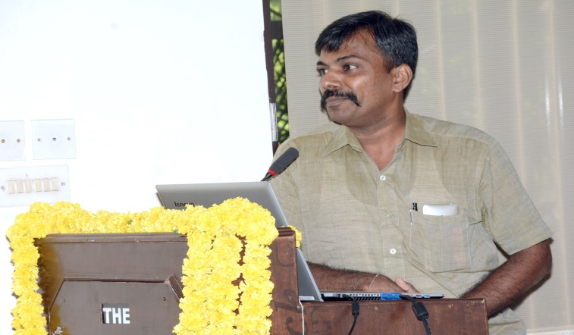 | 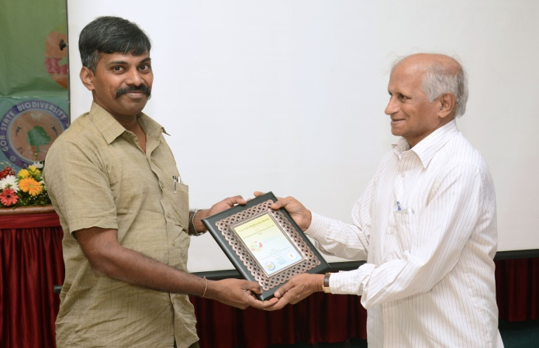
Shri. Paresh Porob, Range Forest Officer, Mhadai Wild Life Sanctuary, delivering lecture on “Biodiversity as Food” | Shri. Paresh Porob receiving the IDB 2015 Memento
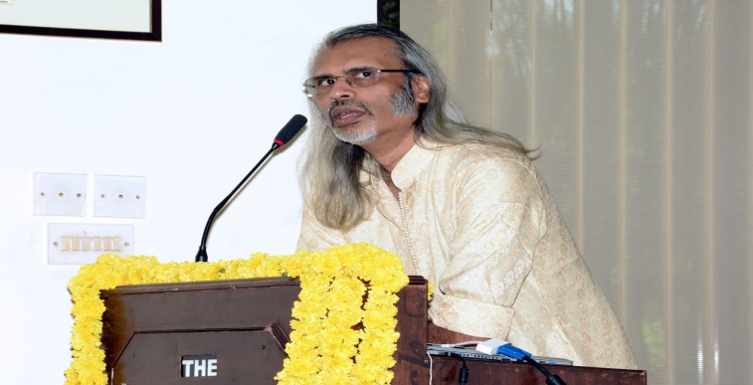 | 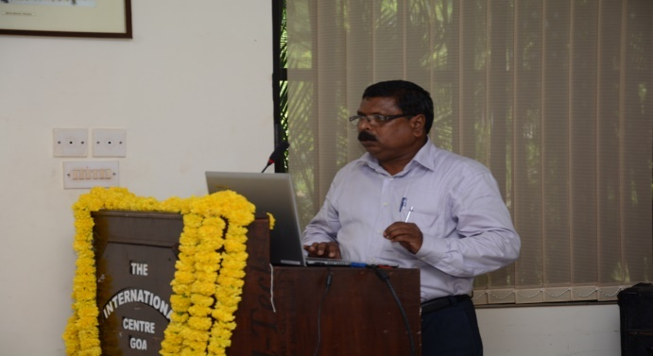
Dr. NandakumarKamat, delivering lecture on “Village Wealth is Bio-Wealth” | Shri. Santosh Gaonkar, delivering lecture on “Indigenous Fish Diversity and its Conservation”
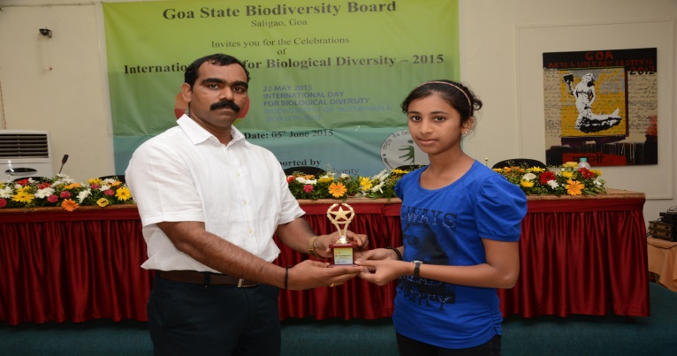 | 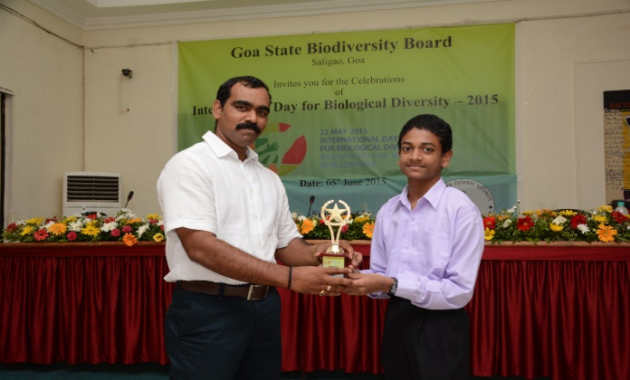
Winner of competition receiving trophy from Member Secretary, GSBB | Winner of competition receiving trophy from Member Secretary, GSBB

